**CSIP5203: Big Data Analytics Applications**

**Time Series Assignment (Coursework 1)**

**P2725708**

(Word count)



Table of Contents

Abstract 4

Problem Description and Methodology 4

Activity 1 4

Exploratory Data Analysis 4

Time Series Visualization 4

Time Series Decomposition 4

Naive Method 4

Fit, forecast and visualization 4

Accuracy Metrics. 4

Comments 4

Average Historical method 4

Fit, forecast and visualization 4

Accuracy Metrics. 4

Comments 4

Activity 2 4

Time Series Decomposition 4

Simple Average Method 4

Fit, forecast and visualization 4

Accuracy Metrics. 4

Comments 4

Exponential Smoothing methods (Single Exponential Smoothing, Holt’s Linear, Holt-Winters) 5

Fit, forecast and visualization 5

Accuracy Metrics. 5

Comments 5

Activity 3 5

Time Series Stationary test and Differencing 5

ACF and PACF 5

ARIMA 5

Fit, forecast and visualization 5

Accuracy Metrics. 5

Comments 5

SARIMA 5

Fit, forecast and visualization 5

Accuracy Metrics. 5

Comments 5

Conclusion 5

References and Bibliography 5

Other Resources 5

Appendix (if necessary) 5

# Abstract

Within this technical report, we are analyzing a real financial time series for a stock named Premier African Minerals Limited with the use of Python programming language along with various time series models and algorithms. We are trying to find out which model and algorithm is the most accurate. This report will help the general public learn about Premier African Minerals Limited’s performance in the past 5 years along with which time series models and algorithms can be used with a good level of accuracy for future research especially datasets involving stocks. The forecasting methods we used are the Naïve method, Average All Historical, Simple Moving Average, Simple Exponential Smoothing, Holt’s Linear, Holt Winter, Arima and Sarima methods. We mainly looked at the Root Mean Square Error (RMSE), Mean Absolute Error (MAE) and Mean Absolute Percentage Error (MAPE) to determine the best model. We also analyzed a time series decomposition with additive and Multiplicative effects. We also briefly looked at diagnostic plots for the Arima model and Sarima model for further analysis. Overall, we found the Naïve Method, Simple Exponential Method and the Arima method to be very similar with the accuracy metrics mentioned above with the Simple Exponential Method being the most accurate with a marginally lower value for MAPE.

# Problem Description and Methodology

I am looking at a historical Time Series dataset for the past five years from 05/12/2018 to 05/12/2023, for a stock named Premier African Minerals Limited. Premier African Minerals Limited was founded in 2007 and is a multi-commodity mining and natural resources development company. The company has a purpose of acquiring and developing mineral properties. They are based in a country in a country named Togo which is in West Africa (Times, n.d.). The current share price as of the present data was 0.23 and has a market cap of £66.42 million as of 18/12/2023.

We are aiming to forecast the values for the share price of Premier African Minerals Limited for 6-12 months using the historical Time Series Dataset we currently have and are aiming to use various forecasting methods such as the Naïve Method, Average Historical Method, Simple Average Method, Exponential Smoothing Methods, ARIMA (Autoregressive Integrated Moving Averages) and SARIMA (Seasonal Autoregressive Integrated Moving Average) Method. We will be then considering the accuracy metrics for each method before concluding the best possible method to predict the share price. We all be looking at three accuracy metrics, these being: Mean Absolute Error (MAE), Root Mean Squared Error (RMSE) and Mean Absolute Percentage Error (MAPE).

# 

Activity 1

# Exploratory Data Analysis

|  | **Close** |
| --- | --- |
| **count** | 60.000000 |
| **mean** | 0.245200 |
| **std** | 0.217366 |
| **min** | 0.023000 |
| **25%** | 0.077750 |
| **50%** | 0.187500 |
| **75%** | 0.333750 |
| **max** | 0.941000 |

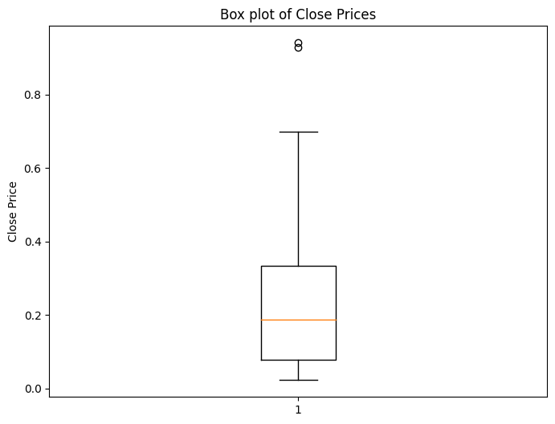[2]:

Figure 1- boxplot to help illustrate the descriptive statistics (quartiles etc.)

Table 1- descriptive statistics for historical time series data

## 

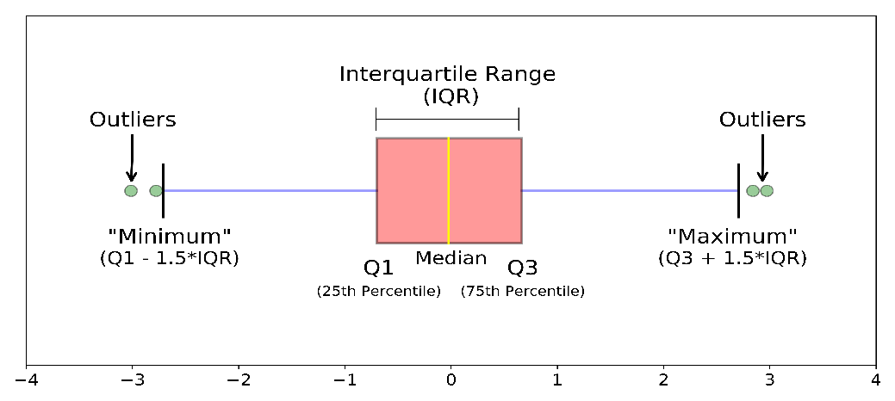Above are some descriptive statistics used to help have a more in depth understanding of the Timeseries dataset we have used for African Minerals Limited. There is also a box- plot diagram used to help illustrate these descriptive statistics. The mean demonstrates the average close price of African Minerals Limited was 0.245 across the five-year period we have used with a count of 60 which shows the number of Historical timeseries values we have been using. The standard deviation (std) which demonstrates the dispersion of the values from the mean is 0.2174. The Q1 value (25th) is 0.078 and the Q3 value (75th) is 0.3338 with the median value (50%) being 0.1875. This would mean the Interquartile range is 0.26. According to the box-plot the max value (0.94) seems to be an outlier.

Figure 2 – diagram to help understand box- plots as a referral to the text above (Galarynk, n.d.)

## 

Figure 3 – codes used for importing relevant libraries, data, creating the correct data frames and creating a Time series graph for African Minerals Limited

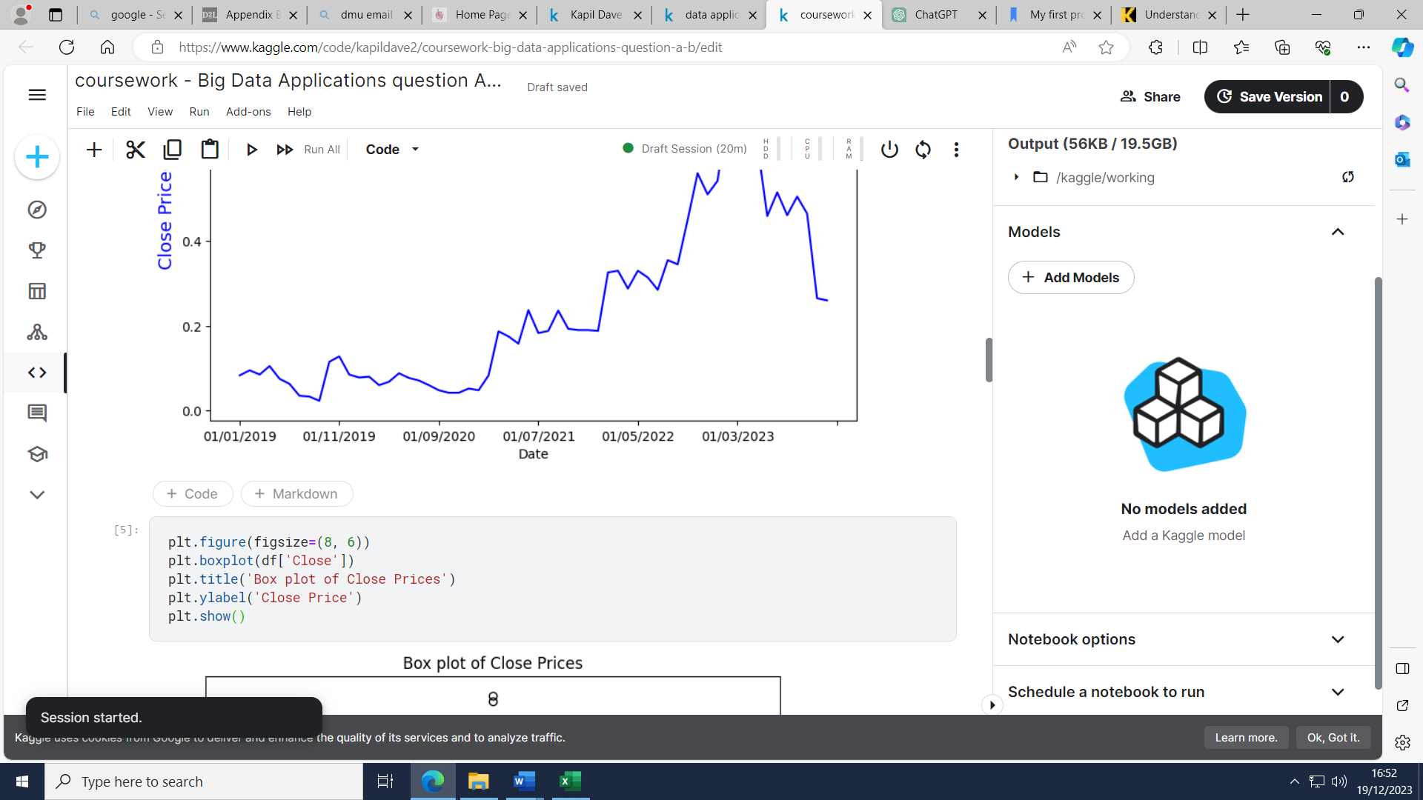

Figure 4 – code to plot boxplot using the historical time series data

## Time Series Visualization

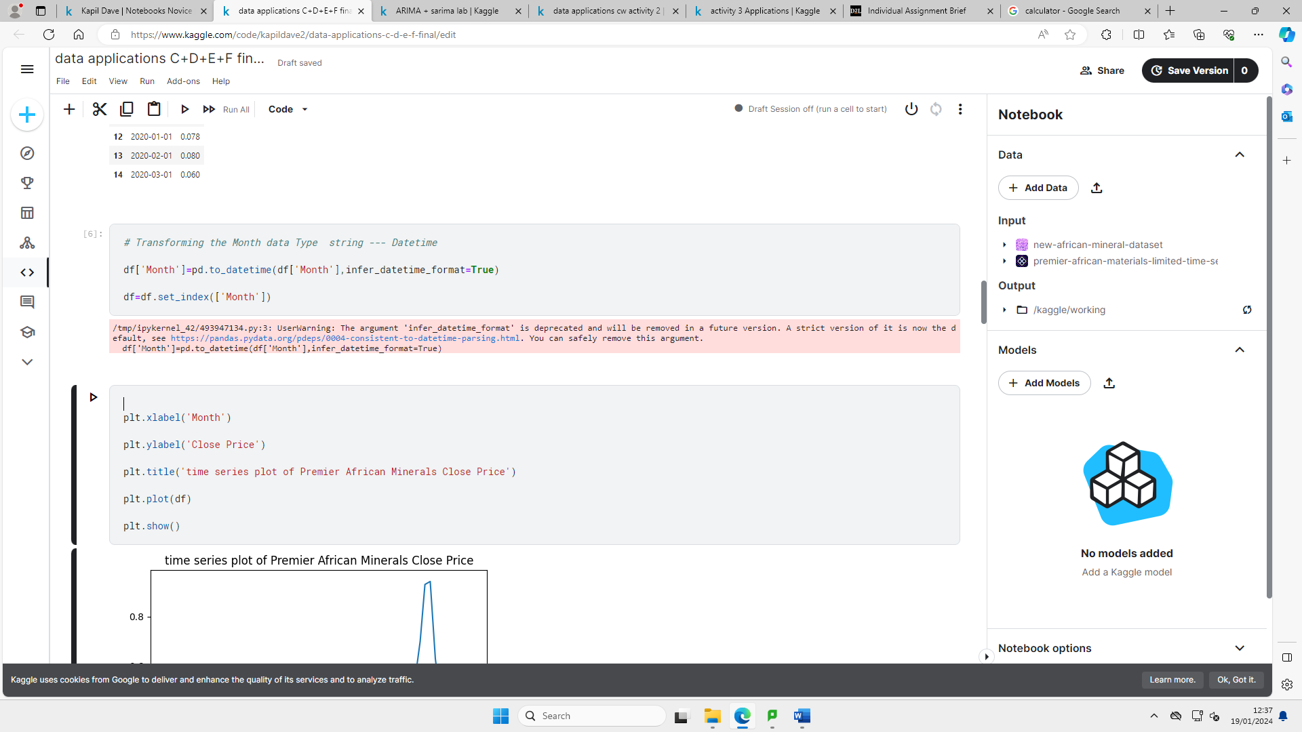

Figure 5 – code to convert month string to datetime and to plot time series graph

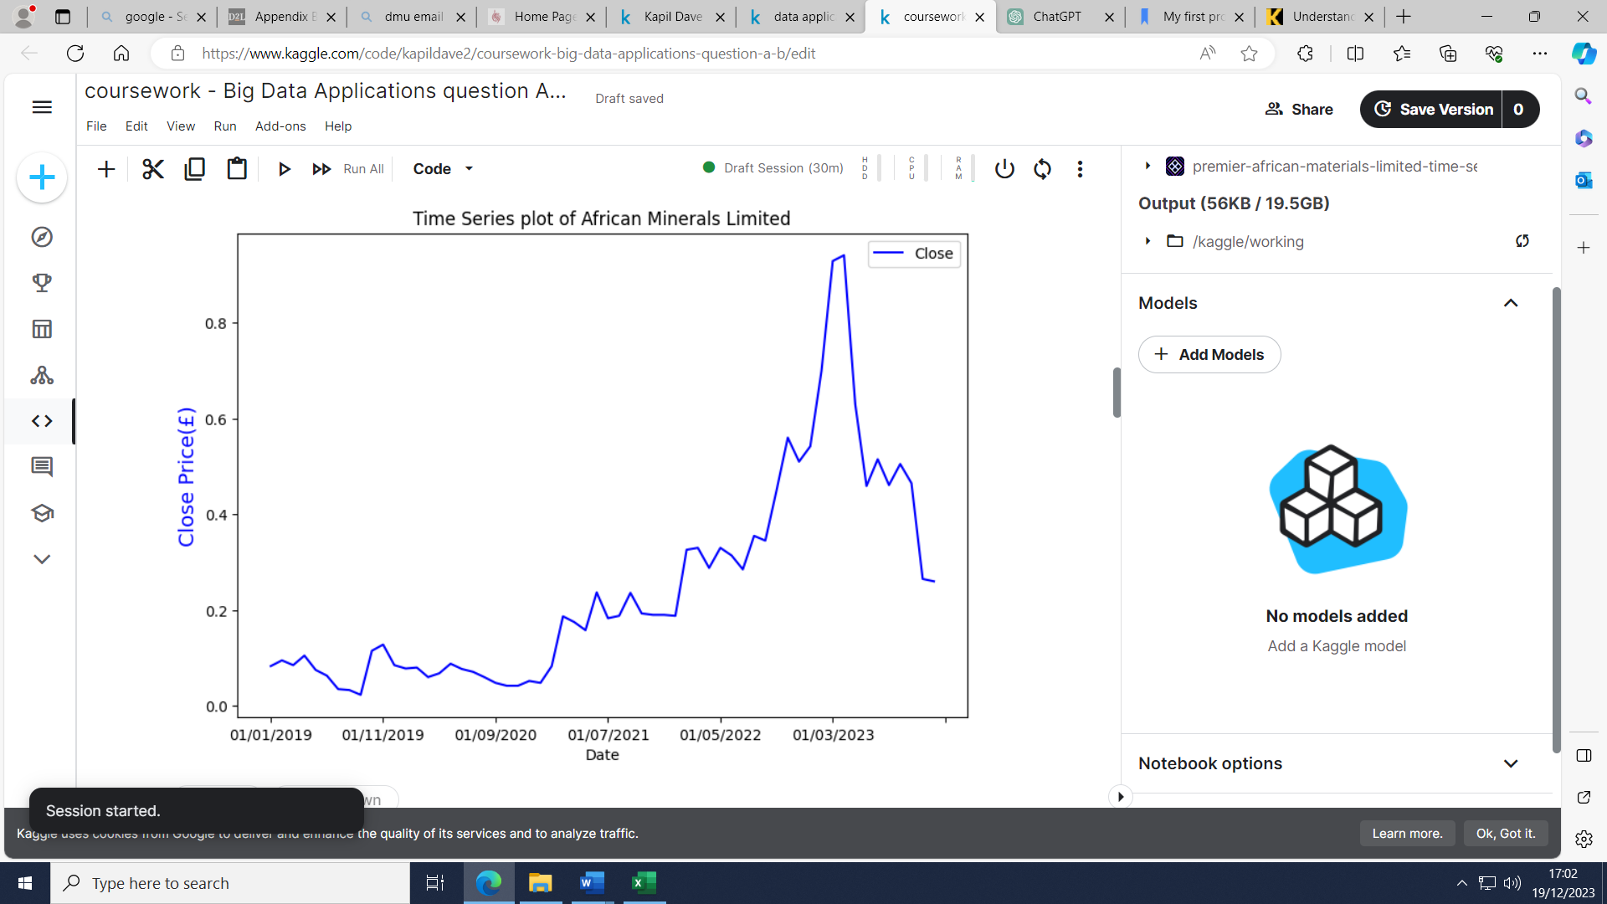

Figure 6 – Time series Graph for African Minerals Limited

## 

Figure 7 – A stacked area chart to further illustrate the trends and magnitude of change for the close price of African Minerals Limited.

After considering both visualizations. We can see the trend of the share price is fairly stable with no major change from the start of 2019 up to the beginning of 2021. Then around mid-2021, there was an upward trend up to the middle of 2023 before there was a sharp drop from then up to the end of 2023. To further prove this 01/02/2021 the share price was 0.083 with a gradual rise to 01/05/2021 up to 0.158. This increased significantly up to 0.94 on 01/04/2023 which was the peak price during the time period. However, this dropped to 0.26 on 01/12/2023.

One of the reasons for the rise of the share price between 2021 and 2023 was due to a rise in demand for Lithium as there are shifts towards electric vehicles which results in a greater demand for Lithium. In fact, Lithium Carbonate prices have tripled in China from 2021 to 2022 (Smith, 2022).

The cause of the drastic decline since April of 2023 is due to the company stating that they will miss a series of production targets which will lead to financial penalties. Investors have become anxious about the company’s messages and lack of clarity for them to meet future Lithium production requirements. On 03/11/2023 the company said that Zulu Lithium Plant was facing several challenges (Magazine, 2023).

## Time Series Decomposition

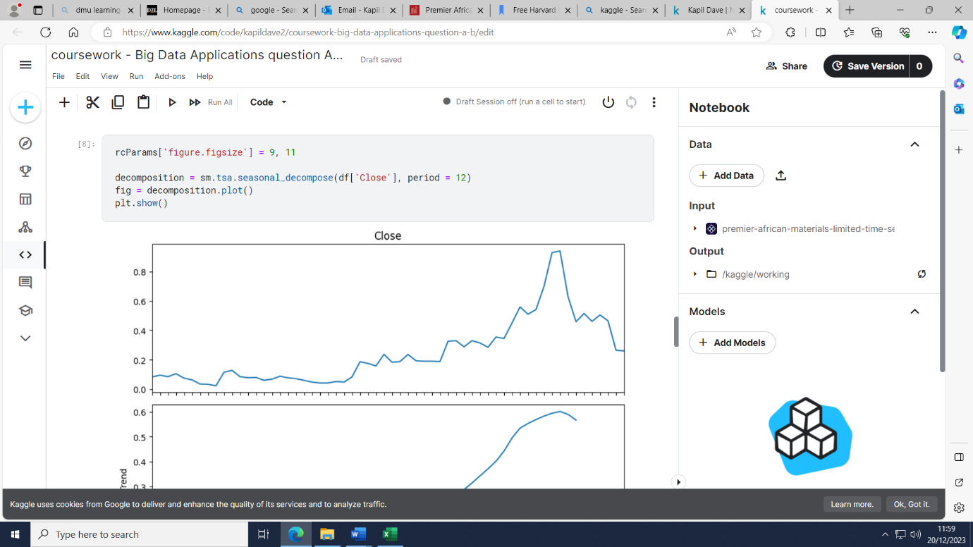

Figure 7 –code and graph for level decomposition component

## 

## 

Figure 8 – code and graph for seasonality decomposition component

## 

Figure 9- code and graph for trend decomposition component

## 

Figure 10 – code and graph for residual decomposition component

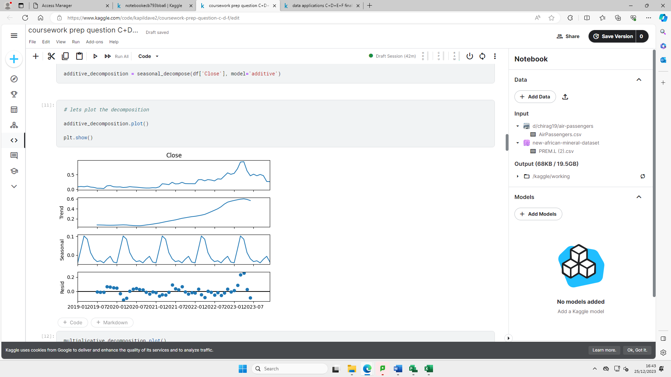

Figure 11 – code and graph for additive decomposition component

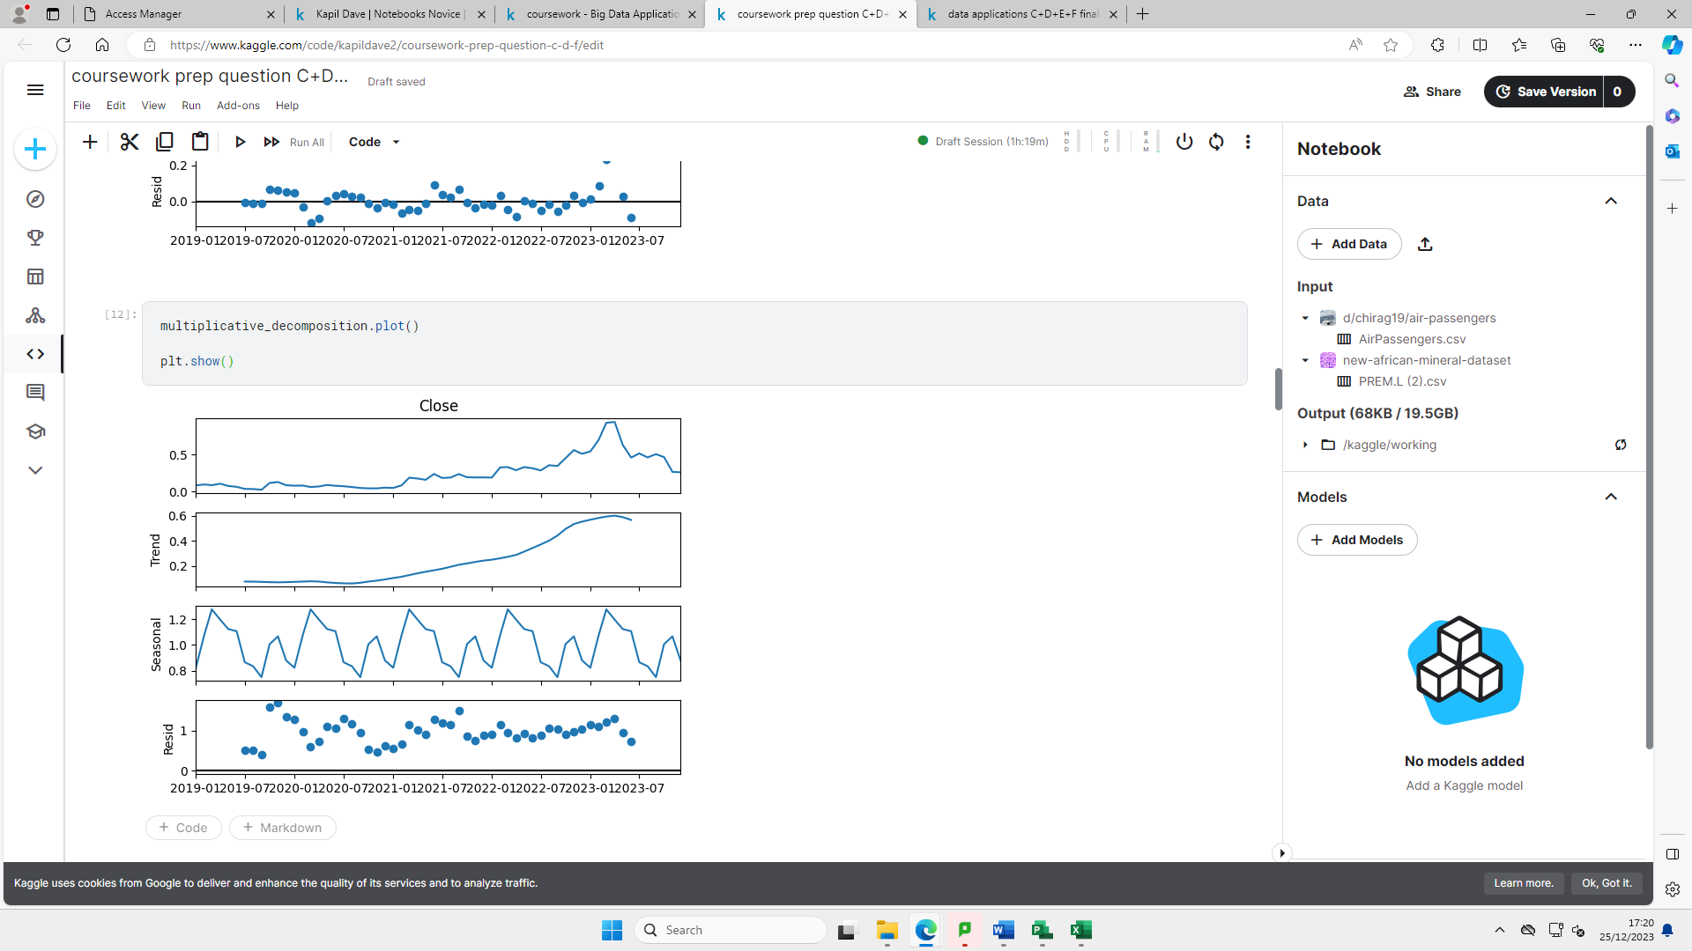

Figure 12 – code and graph for multiplicative decomposition component

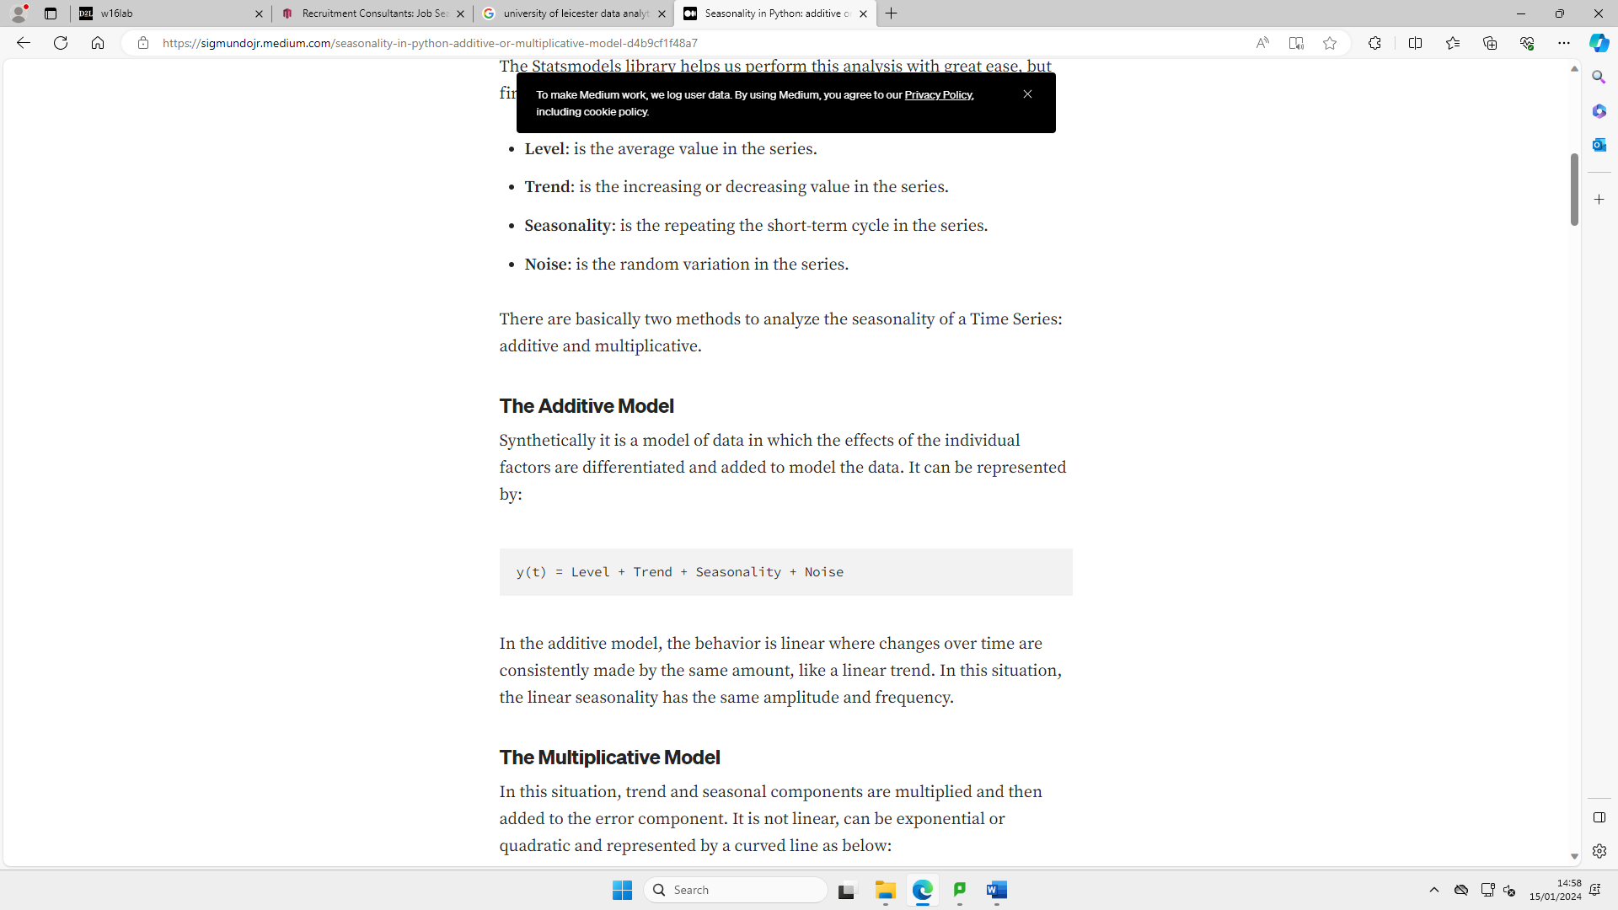

Figure 13 - Additive component (Brownlee, 2017)

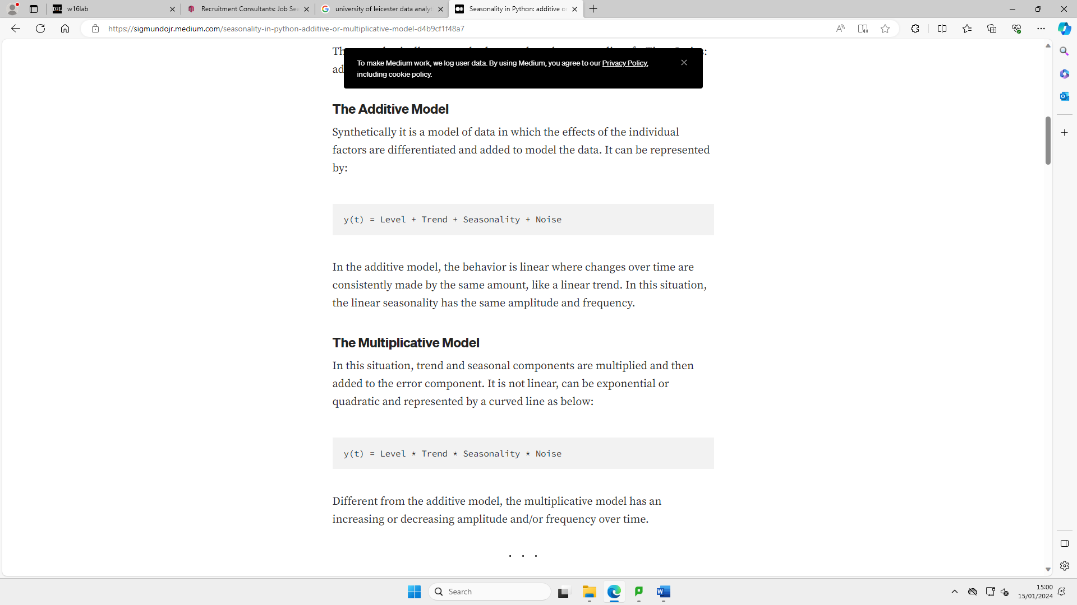

Figure 14 - Multiplicative component equation (Brownlee, 2017)

* Trend= increasing or decreasing in the series
* Seasonality= Is the repeating the short-term cycles in the series
* Residual = everything not captured by trend and seasonal components

The residual value is something very significant when choosing the decomposition. However, the residual value for additive model is closer to 0 and for the multiplicative decomposition it is closer to 1 hence the additive decomposition is a better decomposition to choose (Radečić, 2021).

## Naive Method

This method is very simply using the observed values from the last period and forecasts it for the next period.

### Fit, forecast and visualization

Figure 15- codes to implement Naïve method

### 

Figure 16 – Naïve forecast values

### 

Figure 17 – naïve method forecast visualisation codes and graph

### Accuracy Metrics.

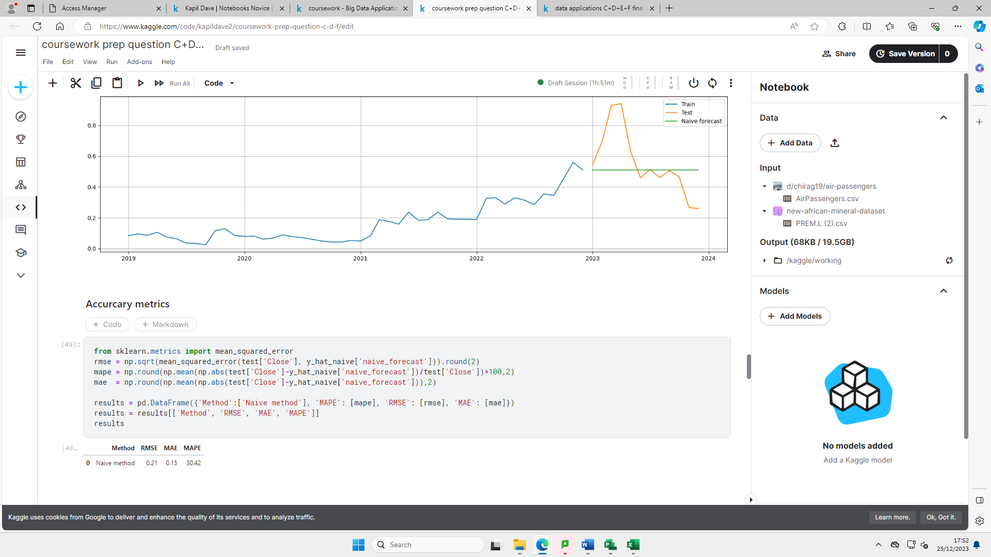

### 

Figure 18 – codes for naïve method accuracy metrics

### 

Figure 19- naïve method accuracy metric values

### Comments

The RMSE (Root Mean Square error) is the Standard Deviation of the residuals. This would inform us of how concentrated the data is from the line of best fit. In this case, the forecasted values seem to differ from the actual values by 0.21 units. The MAE (Mean Absolute Error) is a measure of the average size of the mistakes in a gathering/collection of predictions (Glen, 2022). The MAE value suggests the average size of error is 0.15 units. The MAPE (Mean Absolute Percentage Error) measures the accuracy as a percentage, according to the forecasted value there is a 30.42% error from the actual values. In general, the lower this value the more accurate the prediction of the values (checks, n.d.).

## Average Historical method

This method would use the average of all historical data available on the next period to forecast.

Fit, forecast and visualization

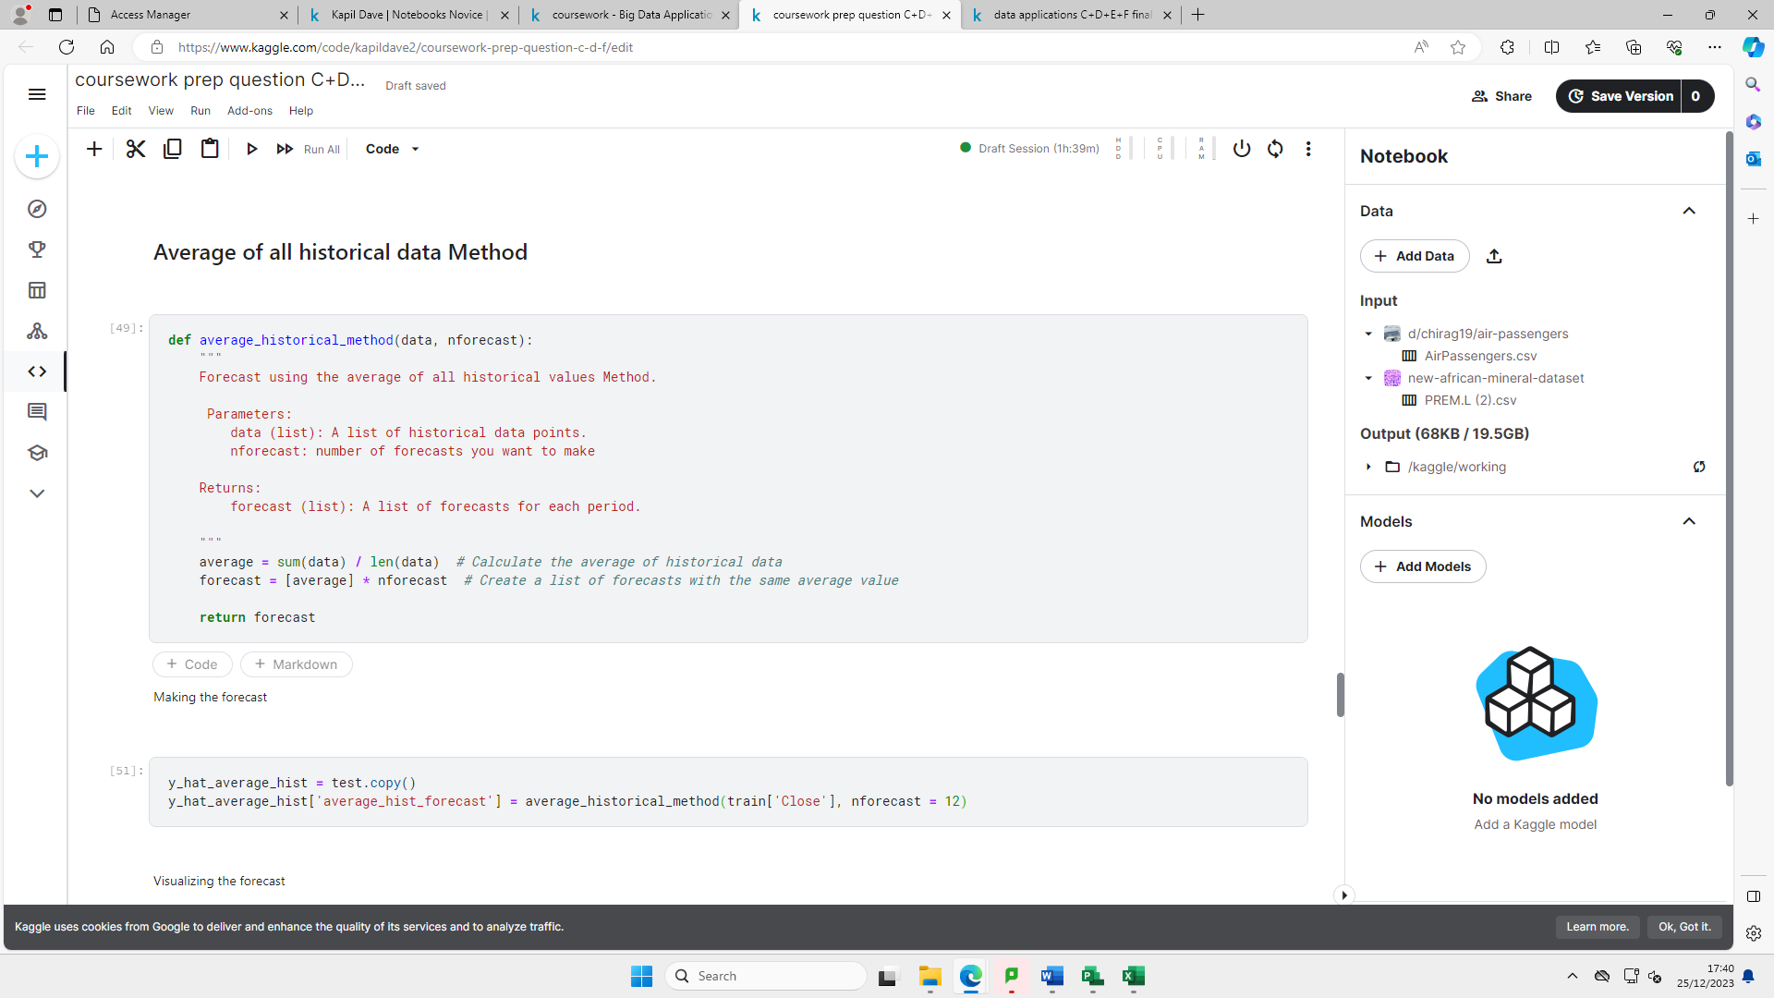

Figure 20 – codes for average all historical data method

### 

### 

Figure 21 – average all historical method forecast

### 

Figure 22- average all historical method visualisation

### Accuracy Metrics.

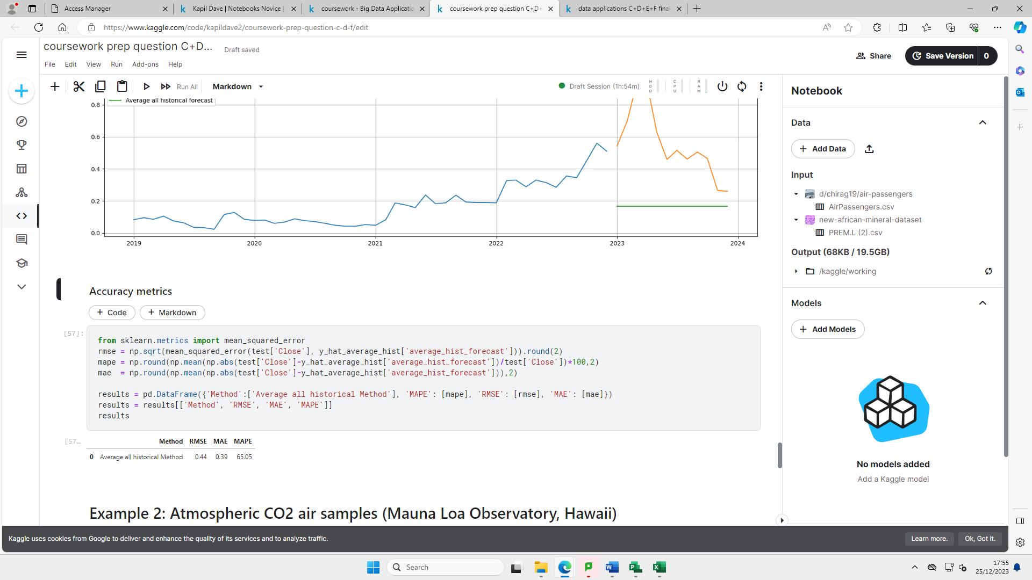

Figure 23- average all historical method accuracy metrics codes + values

### 

### 

### Comments

After considering both sets of accuracy metrics with the Naïve method and the Average all Historical method, the Naïve method seems to be more appropriate with lower RMSE, MAE and MAPE values hence it is a more accurate method to use. In fact, the MAPE value is more than twice as large for the Average All Historical Method. If we consider the RMSE value’s the Average All Historical Method which is 0.44 units is an 109.52% increase from the RMSE value for the Naïve Method hence it is a drastic increase and far less accurate.

# Activity 2

## Time Series Decomposition



## 

Figure 7 –code and graph for level decomposition component

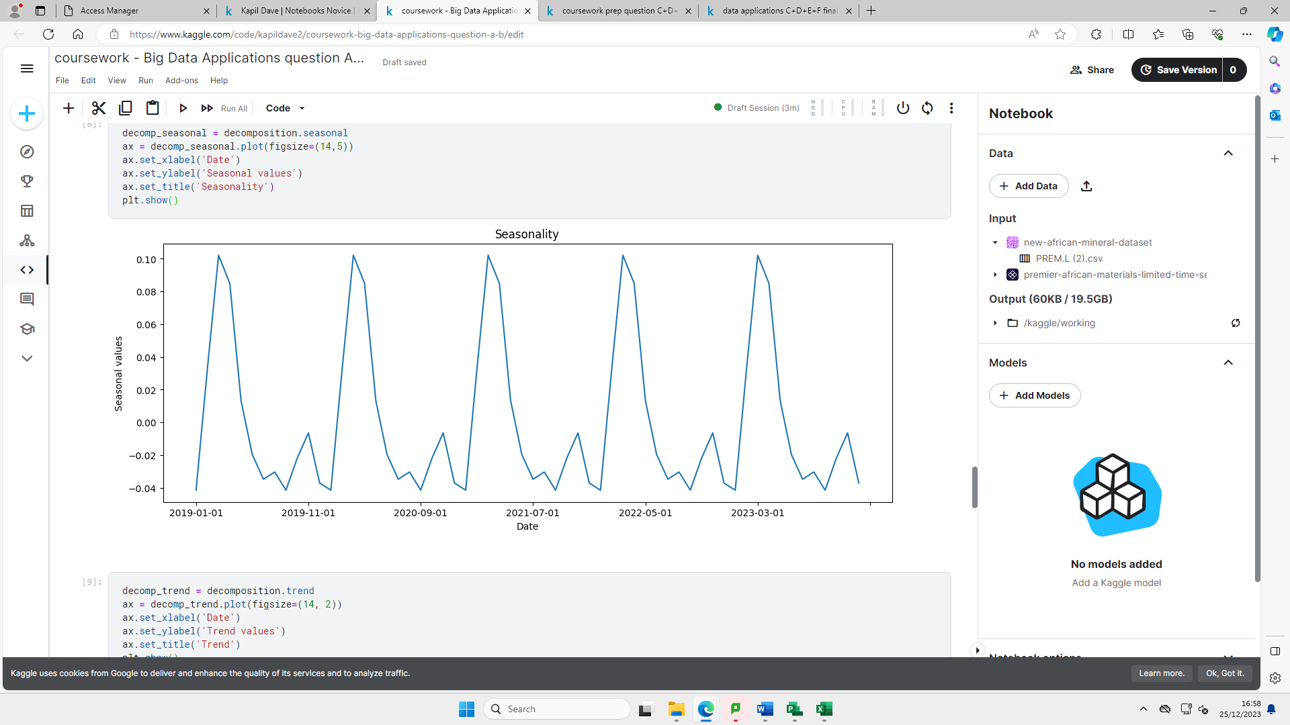

Figure 8 – code and graph for seasonality decomposition component

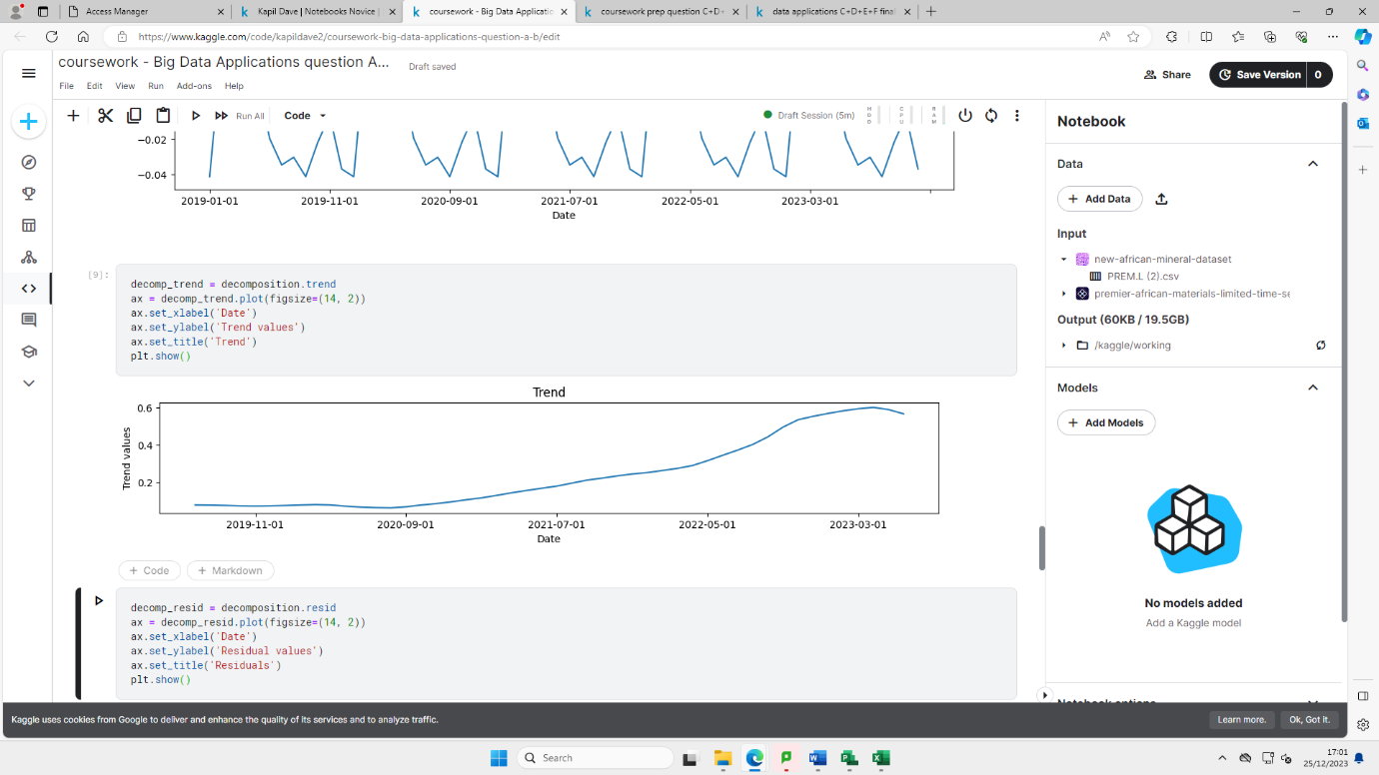

Figure 9- code and graph for trend decomposition component

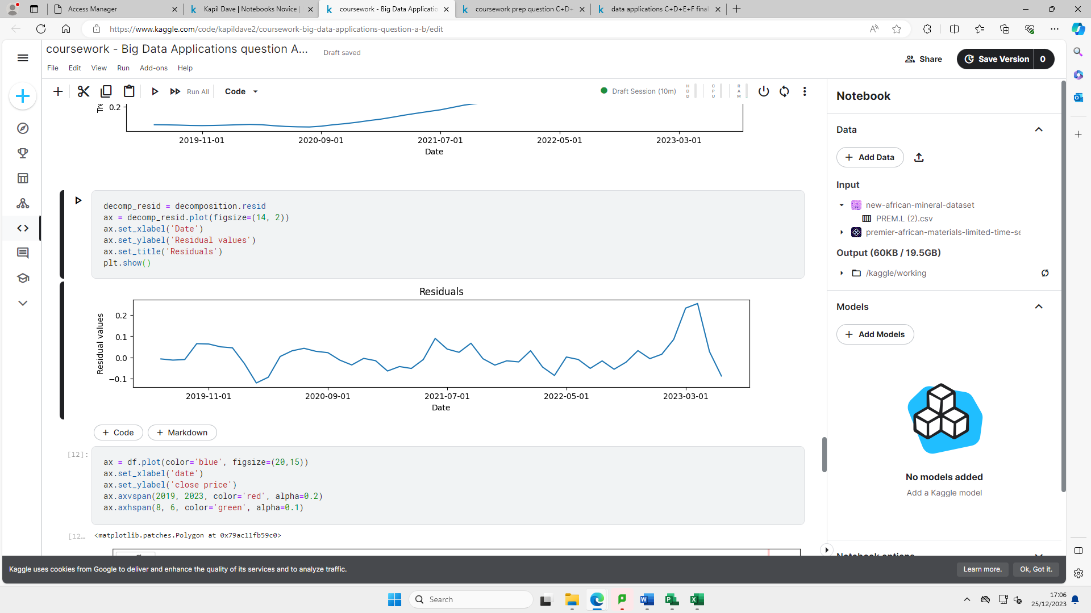

Figure 10 – code and graph for residual decomposition component

## 

Figure 11 – code and graph for additive decomposition component

## 

Figure 12 – code and graph for multiplicative decomposition component

## Simple Average Method

Uses the average of the most recent K data value in the time series as the forecast for the next period.

### Fit, forecast and visualization



Figure 24 – code for simple average method fit, forecast and visualisation

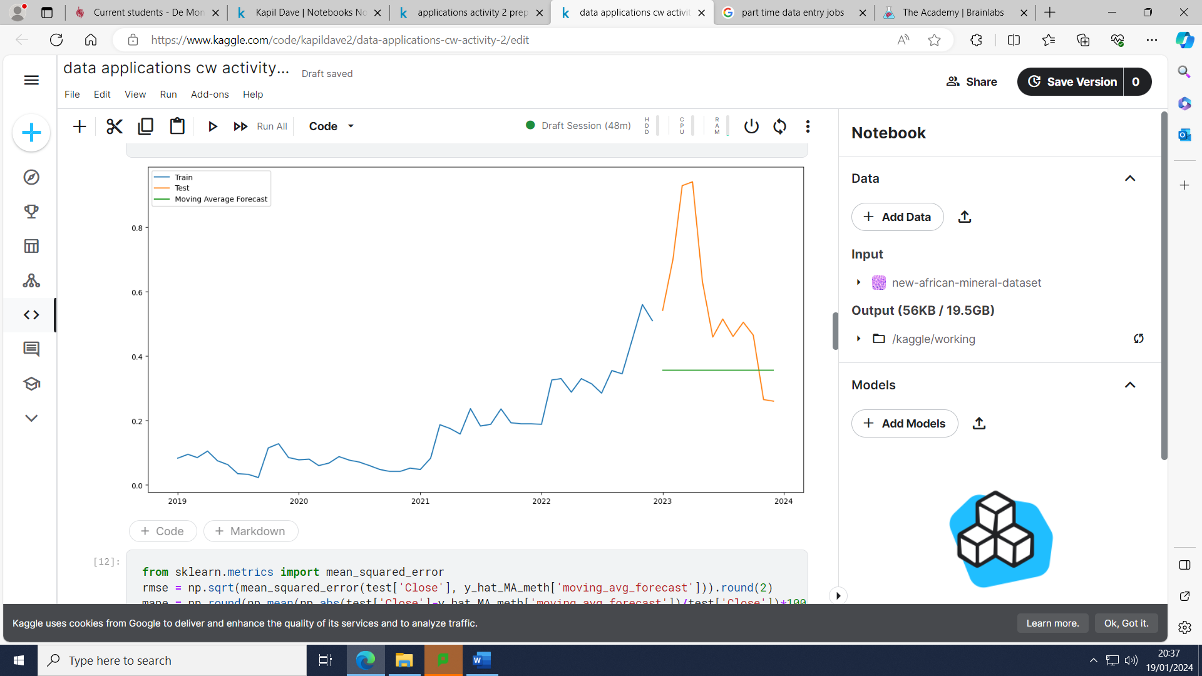

Figure 25- graph for moving average forecast

### 

### Accuracy Metrics.

### 

Figure 26- code and accuracy metric values for Simple Moving Average Method

### Comments

The Root mean square values seems to suggest that the forecasted values seem to differ from the actual values by 0.29 units. The Mean Absolute Error values seem to suggest that the average size of error is 0.23 units for the forecasted values. The Mean absolute percentage error informs us that there is an 37.53% error for the forecasted values from the actual values.

## 

## Exponential Smoothing methods (Single Exponential Smoothing, Holt’s Linear, Holt-Winters)

Exponential smoothing uses a weighted average of past time series values as a forecast.

### Fit, forecast and visualization

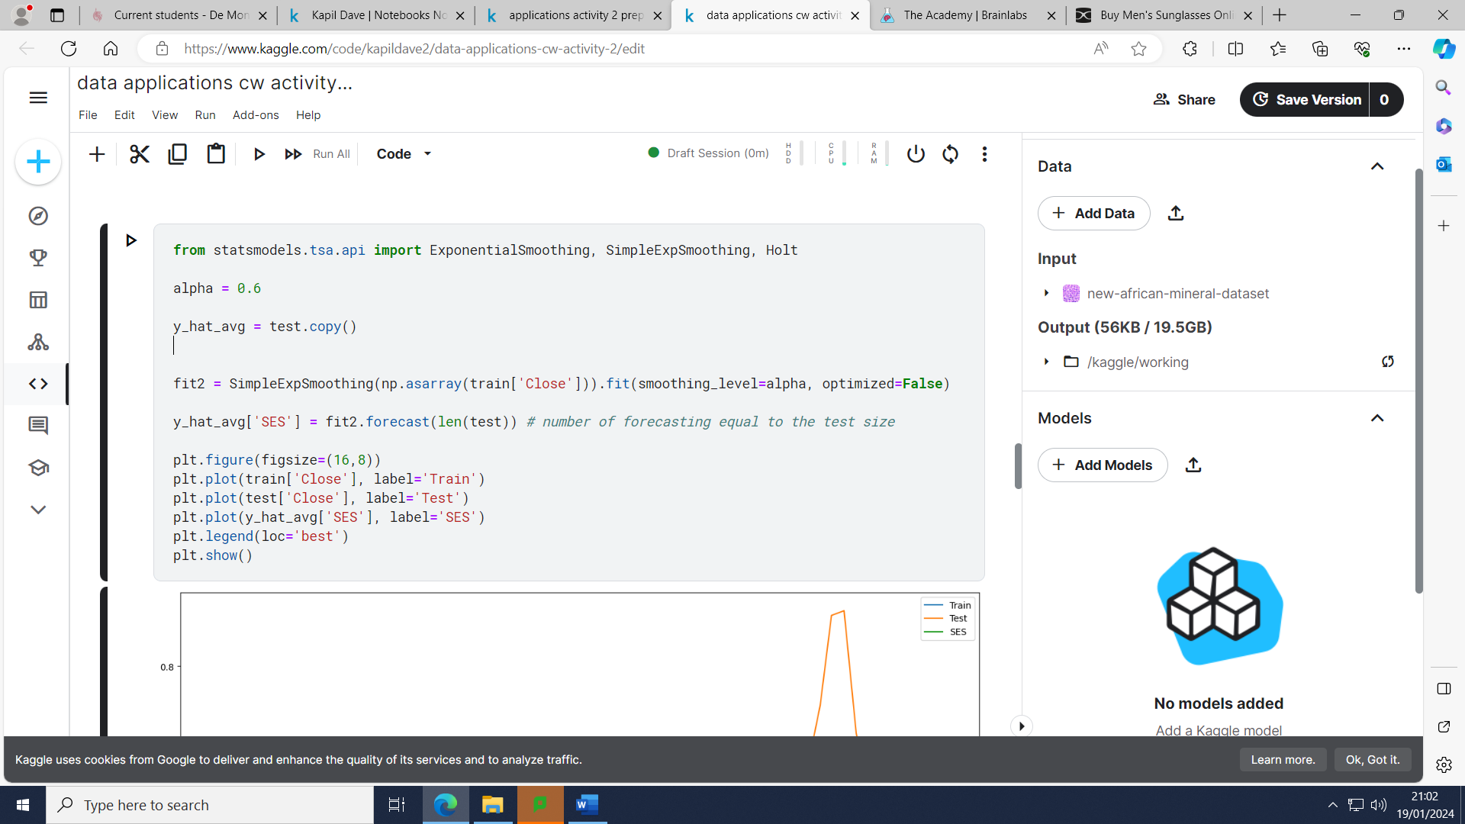

Figure 27- code for single Exponential Smoothing method fit, forecast and visualisation

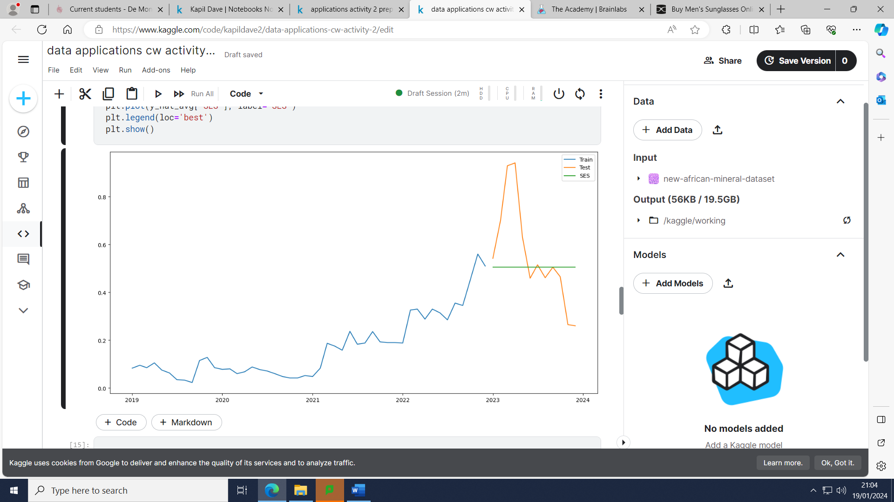

Figure 28 – graph for single exponential smoothing method and it’s corresponding forecast

### 

Figure 29 - code for Holt-Liner method fit, forecast and visualisation.

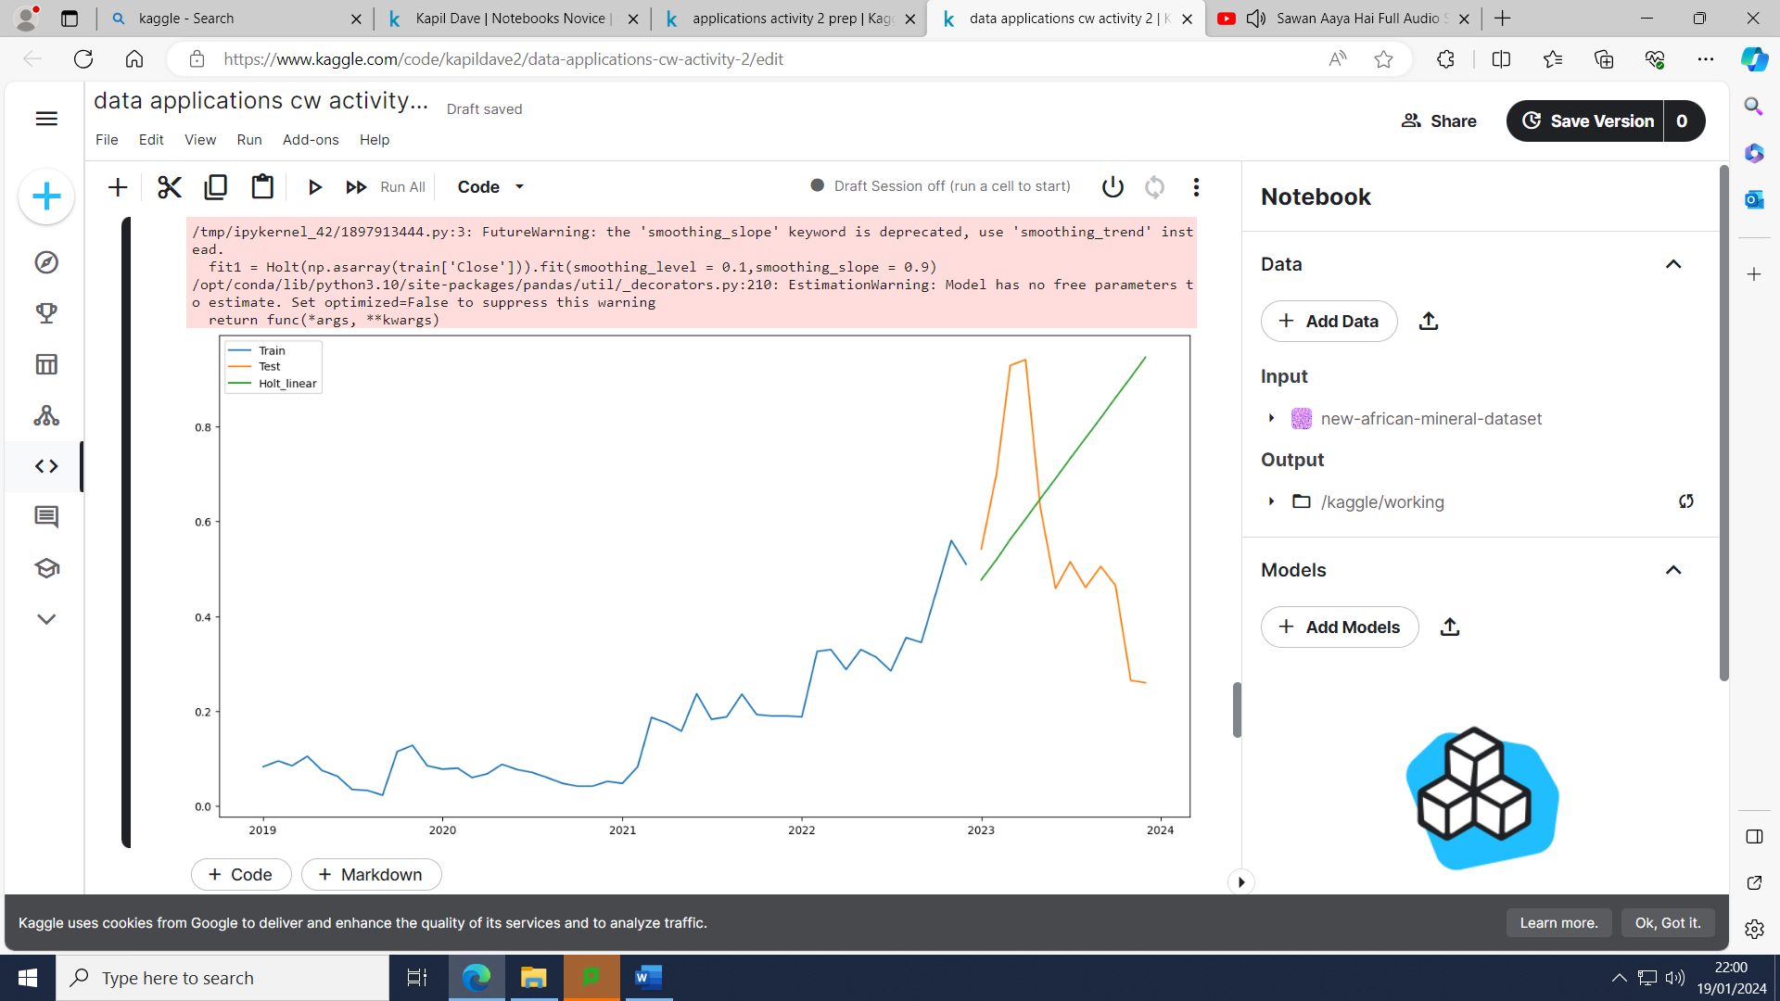

Figure 30- graph for Holt-Linear method and its corresponding forecast

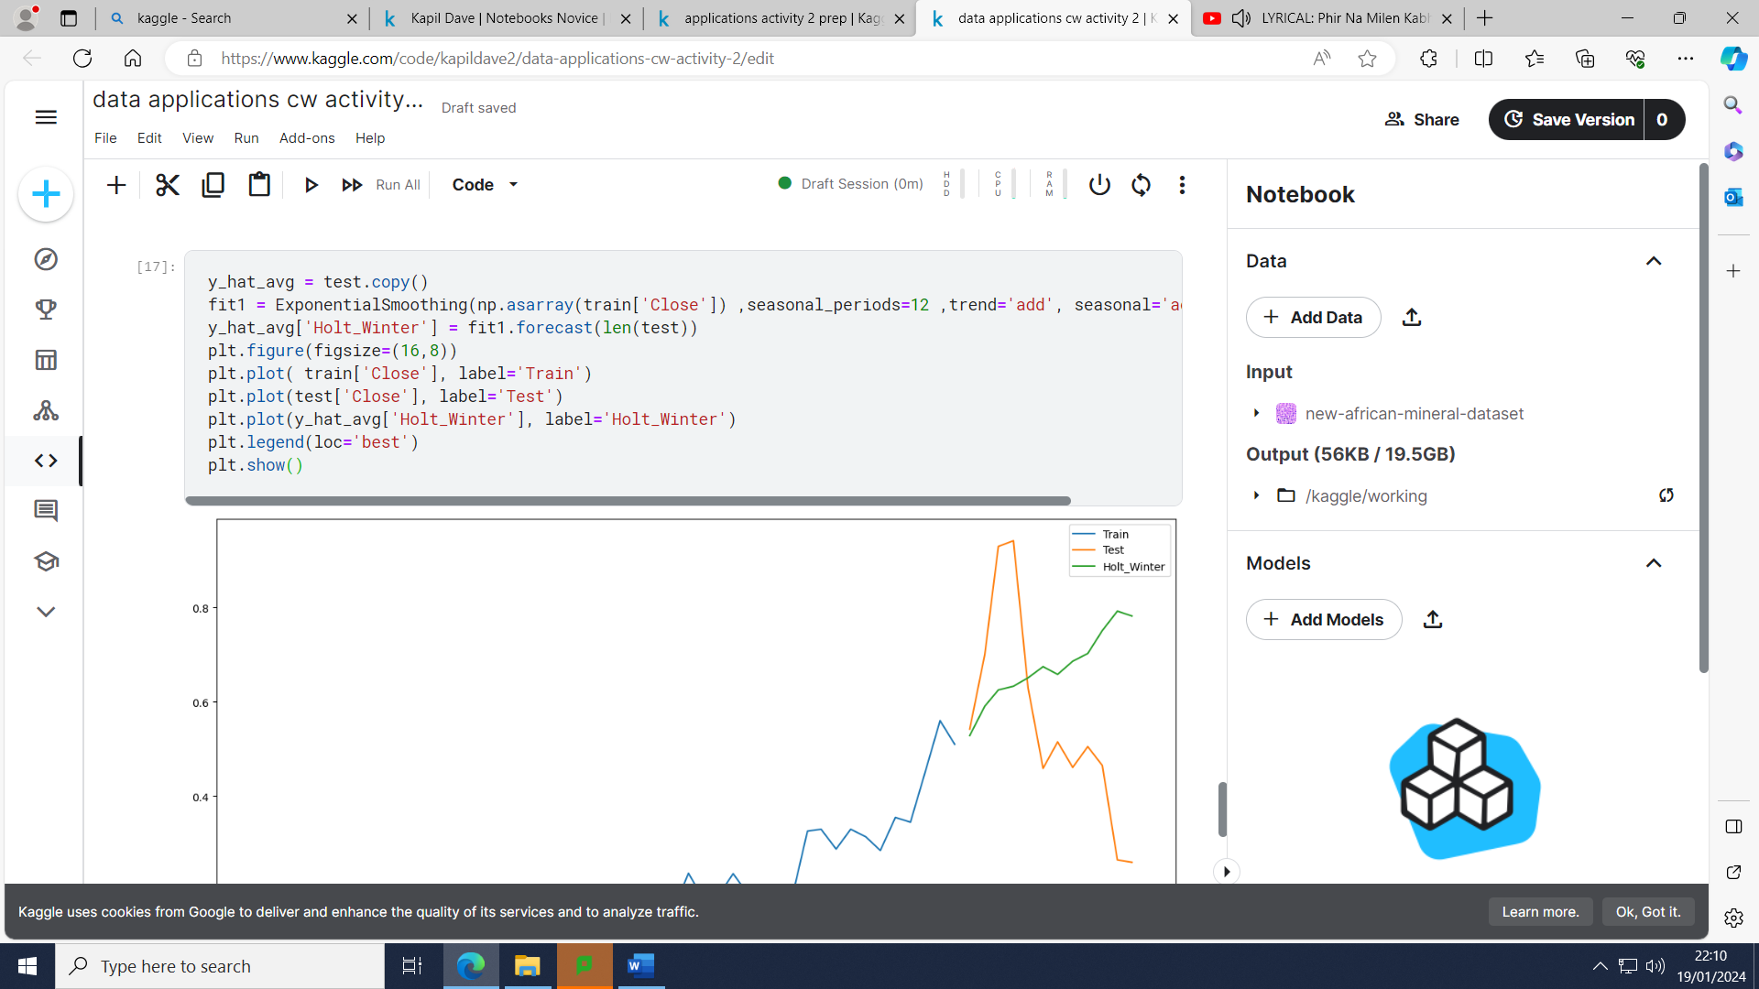

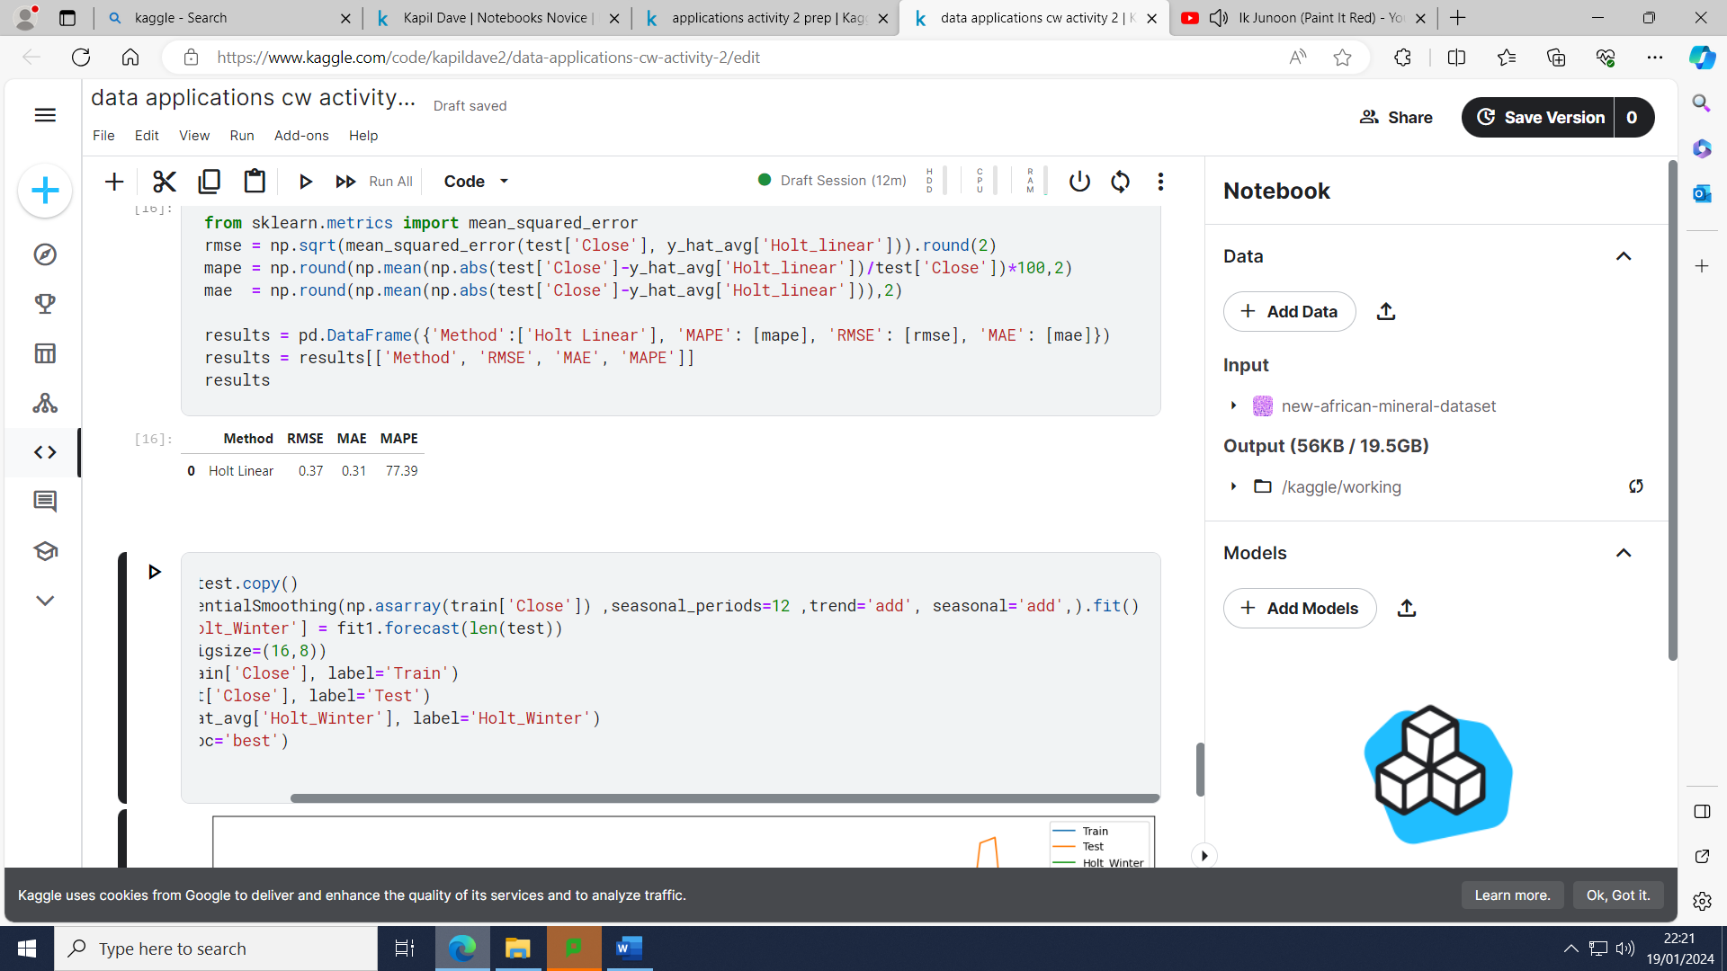

Figure 31- code for Holts Winter Method fit, forecast and visualisation

### 

Figure 32- graph for Holt’s winter method and its corresponding forecast

### Accuracy Metrics.

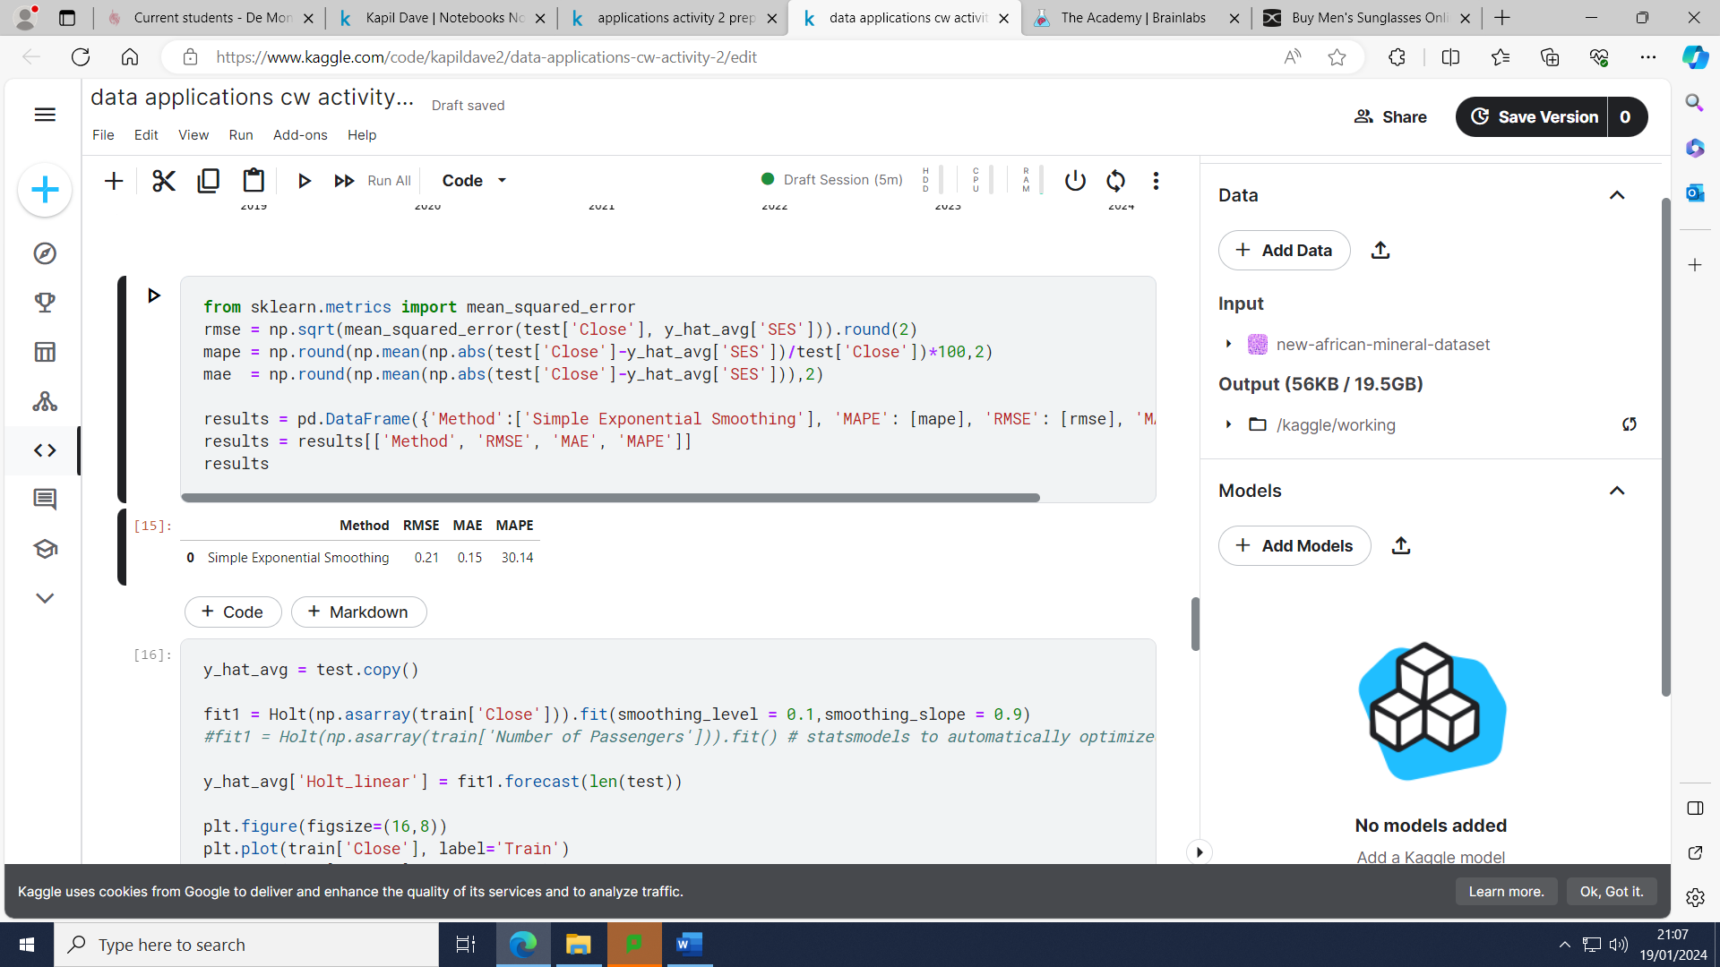

Figure 33- code for Simple Exponential Smoothing method accuracy metrics and its corresponding values

### 

Figure 34 – code for Holt Linear method accuracy metrics and its corresponding values

### 

Figure 35 – code for Holt Winter Method accuracy metrics and it’s corresponding values

### Comments

After considering all three methods and their relative accuracy metric values it seems as if the Simple Exponential Smoothing values is the best method to choose with the lowest RMSE, MAE and MAPE values with the RMSE values suggesting that the forecasted values differ from the actual values by 0.21 units, the average size of error being 0.15 units and the percentage error being 30.14%. For comparison’s sake if we use the RMSE value, the Simple Exponential Method is 55% more accurate compared to the Holt’s Linear Method and 32% more accurate compared to the Holt’s Winter Method. We can also visually see from the graph of how inaccurate the Holt Winter and linear seem to be. The other two method’s do not seem ideal either on observation.

# Activity 3

## Time Series Stationary test and Differencing



Figure 36- Dickey- Fuller test code and values

## According to the P-value is above the significance value of 0.05 hence we can assume that the series is not stationery. This means we should go ahead with finding the order of differencing.

## 

Figure 37 – code to find order of differencing

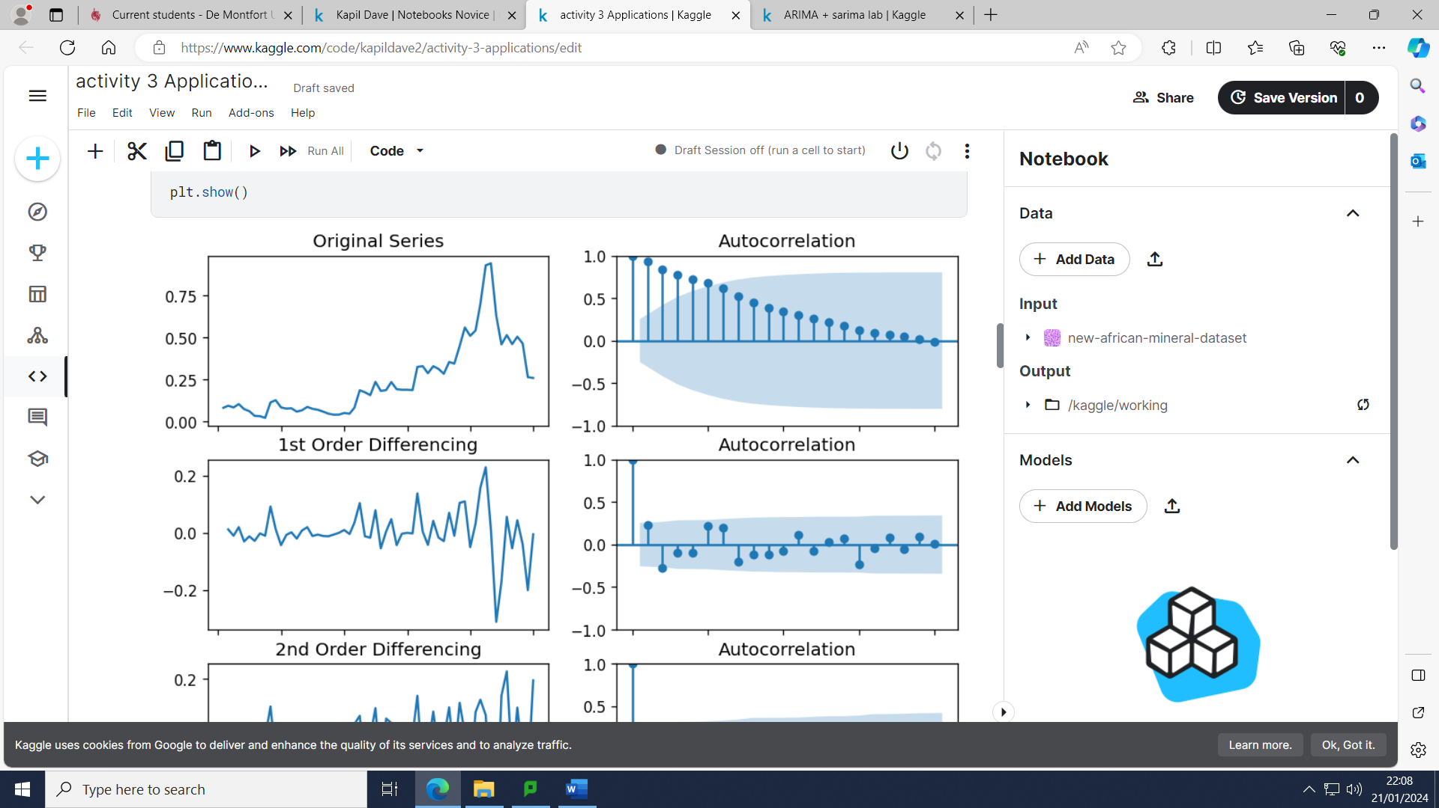

Figure 38 – graph for original series and 1st order differencing with its relative autocorrelation graph.

## 

Figure 39 - graph for 2nd order differencing with its relative autocorrelation graph.

## From the graph above we can see the time series reach stationarity with one order of differencing hence the value of d=1.

## ACF and PACF

## 

Figure 40- PACF code and graph for 1st differenced series

P is the order of the auto- regressive term.

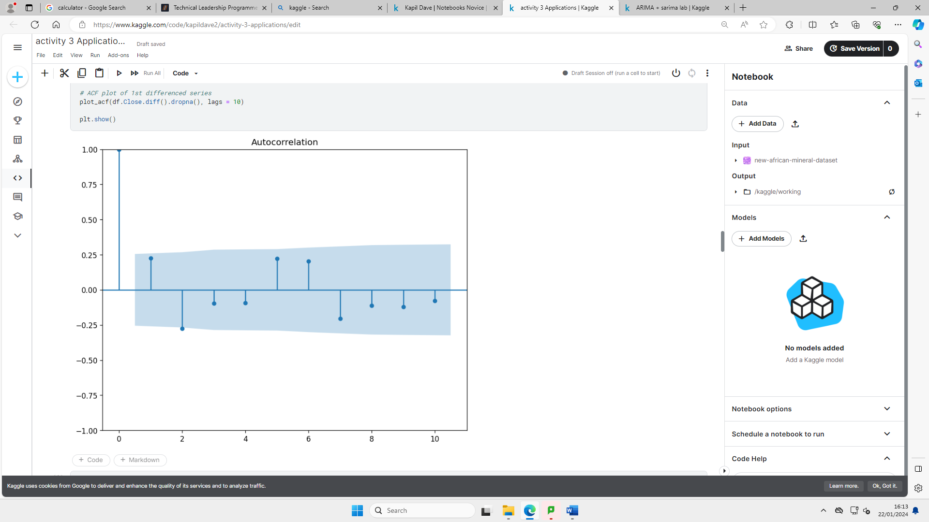According to the graph above the PACF lag 2 seems to be crossing the significant line hence we can keep the p value to be 2.

Figure 41- The code for ACF plotting and 1st differenced series.

Q is the order of the moving average term.

We can keep our q value as 0 in this case as the other lags are mostly within the significant line

## ARIMA

Arima (Auto-regressive integrated moving average) is used to predict the future values of a time series using its past values and forecast errors. Auto-regressive models predict future behaviour where there is some correlation between past and future data.

### Fit, forecast and visualization

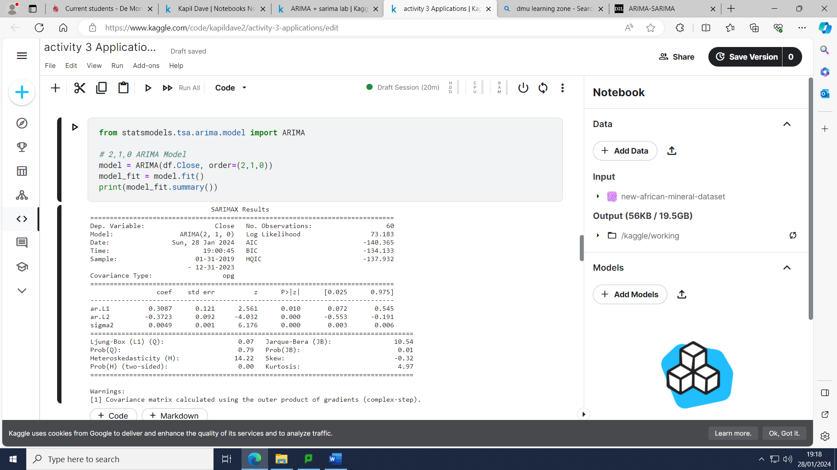

Figure 42- code to implement the stats model package for Arima and its respective values

### 

Both of the P values for AR1 and AR2 are highly significant as they are both below 0.05. This model seems to have the lowest AIC value.

### 

Figure 43- code and graph for the residual error graph for Arima

### 



Figure 44- codes to create training and testing for Arima model.

According to the graphs above we can see the residual error does not seem to have a mean close to 0 (the graph does not seem to be symmetrical) and does not have a uniform variance.

Figure 45- codes to build, forecast and plot Arima method forecast using and the training model.

### 

### 

Figure 46- graph for Arima model along with its forecast and actual values

### Accuracy Metrics.



Figure 47 – codes for forecast accuracy for the Arima model with accuracy metric values

### 

Figure 48- codes and graph for diagnostic plots for Arima model

### 

Comments

The Mean Absolute percentage error suggests that the percentage error is 30.2% which is reasonable however it could definitely be better. The residual errors do not fluctuate around zero which is not a good sign and the variance is not uniform. The Histogram does not seem to have a symmetric distribution with the density plot suggesting normal distribution with mean slightly shifted towards the left. The Theoretical Quantiles shows that there are a few dots around the central area where the red line touches them which again is not ideal as it shows the distribution is skewed. Ideally all the lags should be within the significance line in the correlogram (except the lag 0), this is not the case hence there is some pattern in the residual error which are not explained in the model.

## SARIMA

This method is similar to Arima however it uses seasonal differencing, we can also call this model the Seasonal Arima model.

### Fit, forecast and visualization

### 

Figure 49 – code to decompose the data and check the seasonality

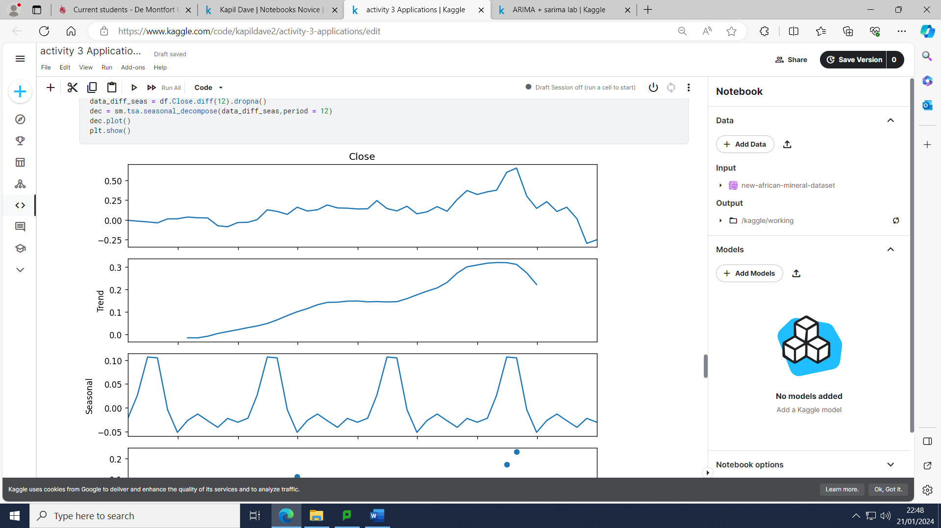

Figure 50 - decomposition to see if there is a seasonal component

### 

### 

Figure 51 – code to fit Sarima model

### 

Figure 52 – Sarima Model fit

The P value of AR2 is highly significant as it below 0.05.

### 

Figure 53 – code to build, forecast and plot Sarima model.

### 

Figure 54- Sarima model plot for forecasting vs actuals.

### Accuracy Metrics.

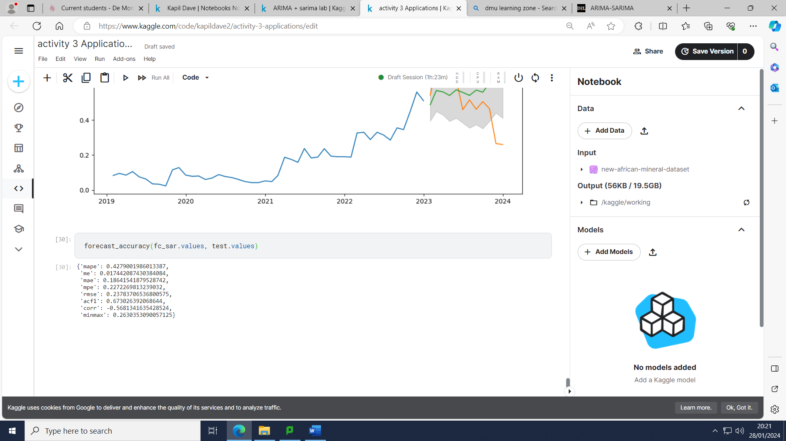

Figure 55- Sarima model forecast accuracy codes and accuracy metrics

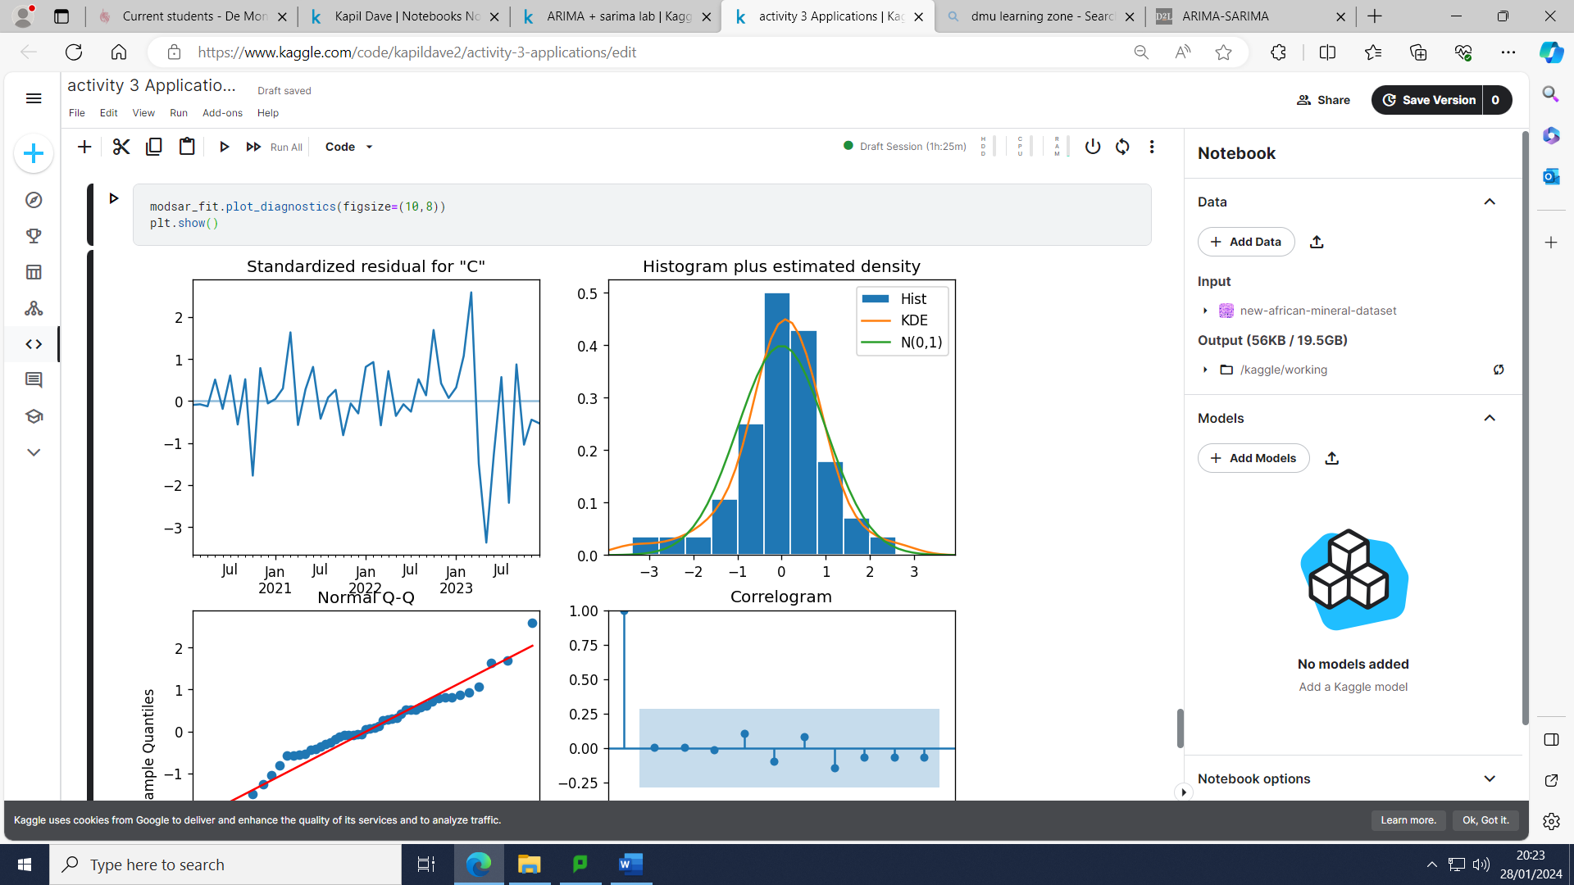

### 

### 

Figure 56- codes and graph for diagnostic plots for Sarima model

### 

Figure 57- code and graph for the residual error graph for Sarima

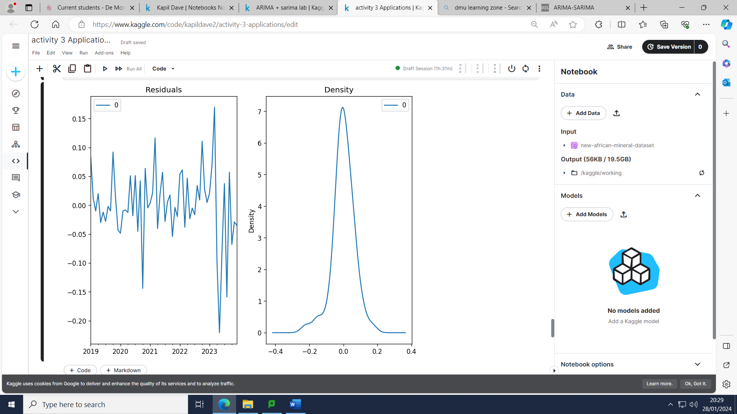

### Comments

After considering all the graphs and accuracy metrics it is clear that the Arima model (2,1,0) seems to be more appropriate with the RMSE values being lower with the Arima model with the Sarima model having a RMSE value of 0.2378 which is an increase of 10.00% from the Arima Model which is not as drastic increase as the previous increases mentioned earlier. After visually observing the graph for the Sarima model it is evident that the forecast is very different to the actual values (the Arima model is not very promising either). The diagnostic plots such as the Residual errors do not seem to have a mean close to zero and also a lack of uniform variance. The Histogram density plot seems to be slightly skewed to the right. Only a few of the dots are barely touching the straight line towards the end of the graph. In terms of the Correlogram, the lags seem to be within the line of significance which is a positive sign. Overall, both models are far from perfect but in this case the Arima model is slightly more accurate as compared to the Sarima model. In general, Sarima method would be more appropriate for data where there is repeating patterns such as when analysing the sales of Winter jackets whereas the stock market can be quite volatile hence does not exhibit distinct seasonal patterns (Artley, 2022).

.

# Conclusion

Table 2- summary of forecasting methods with their accuracy metrics

|  |  |  |  |
| --- | --- | --- | --- |
| Forecasting method | Accuracy metrics | | |
| RMSE | MAE | MAPE (%) |
| naive | 0.21 | 0.15 | 30.42 |
| Average all historical | 0.44 | 0.39 | 65.05 |
| Simple moving average | 0.29 | 0.23 | 37.53 |
| Simple Exponential smoothing | 0.21 | 0.15 | 30.14 |
| Holt Linear | 0.37 | 0.31 | 77.39 |
| Holt Winter | 0.29 | 0.24 | 59.19 |
| Arima | 0.21 | 0.15 | 30.22 |
| Sarima | 0.24 | 0.19 | 42.79 |

After considering all the different forecasting methods along with their accuracy metrics from the table above, the Naïve method alongside the Simple Exponential Smoothing method and the Arima method seem to have the best accuracy in terms of the RMSE, MAE and MAPE value with Simple Exponential Smoothing method being the best method to choose with a slightly lower MAPE value.

# References and Bibliography

Times, F. (n.d.). *Premier African Minerals Ltd, PREM: LSE profile - FT.com*. [online] markets.ft.com. Available at: https://markets.ft.com/data/equities/tearsheet/profile?s=PREM:LSE [Accessed 18 Dec. 2023].

Galarynk, M. (n.d.). *Understanding Boxplots*. [online] KDnuggets. Available at: https://www.kdnuggets.com/2019/11/understanding-boxplots.html [Accessed 19 Dec. 2023].

Smith, J. (2022). *What on earth’s going on with the Premier African Minerals share price?* [online] The Motley Fool UK. Available at: https://www.fool.co.uk/2022/11/01/what-on-earths-going-on-with-the-premier-african-minerals-share-price/ [Accessed 20 Dec. 2023].

‌

Magazine, U.I. (2023). *Premier African Minerals: is it now time to buy?* [online] UK Investor Magazine. Available at: https://ukinvestormagazine.co.uk/premier-african-minerals-is-it-now-time-to-buy/#:~:text=Premier%20African%20Minerals%20shares%20have [Accessed 20 Dec. 2023].

‌

Radečić, D. (2021). *Time Series from Scratch — Decomposing Time Series Data*. [online] Medium. Available at: https://towardsdatascience.com/time-series-from-scratch-decomposing-time-series-data-7b7ad0c30fe7.

‌

Glen, S. (2022). *RMSE: Root Mean Square Error*. [online] Statistics How To. Available at: https://www.statisticshowto.com/probability-and-statistics/regression-analysis/rmse-root-mean-square-error/.

checks, deep (n.d.). *What is Mean Absolute Error*. [online] Deepchecks. Available at: https://deepchecks.com/glossary/mean-absolute-error/ [Accessed 22 Jan. 2024].

Brownlee, J. (2017). *How to Decompose Time Series Data into Trend and Seasonality*. [online] Machine Learning Mastery. Available at: https://machinelearningmastery.com/decompose-time-series-data-trend-seasonality/.

Artley, B. (2022). *Time Series Forecasting with ARIMA , SARIMA and SARIMAX*. [online] Medium. Available at: https://towardsdatascience.com/time-series-forecasting-with-arima-sarima-and-sarimax-ee61099e78f6.

‌

# Other Resources

# Appendix (if necessary)